Application of corrected selectivity to refine/identify/improve spatial growth patterns/variation in northeast pacific sablefish (*Anoplopoma* *fimbria*)

Or

Selectivity Correction does/does not markedly improve detection of spatial growth variation in northeast pacific sablefish

Maia Kapur, Melissa Haltuch, [others], Andre Punt

Keywords: growth, von Bertalanffy, stock assessment, sablefish, spatial variability, selectivity

# Abstract

# Introduction

Sablefish (*Anoplopoma fimbria*) are a highly mobile, long-lived, valuable groundfish that have high movement rates (10 – 88% annual movement probabilities across Alaska, Hanselman et al. 2015) and range from Southern California to the Bering Sea. Concurrent sablefish population declines across the entire range during the past few decades have increased concern about the populations’ status and causes of this downward trend. Traditionally, sablefish stock assessment and management has occurred independently at regional scales, namely Alaska, British Columbia, and the US West Coast, assuming that these are closed stocks. However, recent genetic work has shown that NE Pacific sablefish are not genetically distinct between these traditional management areas (Jasonowicz et al., 2017), though there is evidence for differences in growth rate and size-at-maturity throughout the range (McDevitt, 1990). This suggests that the current delineation of assessment and management regions is incongruent with the stock’s actual spatial structure and motivates research that would enable the construction of a population dynamics model which represents the spatial heterogeneity of sablefish throughout their range.

Growth rates of fish within a population, which are generally parameterized using the von Bertalanffy growth function (VBGF, von Bertalanffy, 1957) can be influential on stock assessment results (Punt, 2003). Parameter estimates for sablefish are usually based on survey data acquired from chartered commercial trawl or longline vessels (Table 1). It is preferable to obtain estimates from a survey, because fishery-dependent information can be heavily biased due to targeting or gear selectivity (Ricker, 1969). *More detail here on survey data acquisition and observed regional stratification; include map of regions.*

There has been a resurgence of efforts to quantify spatial growth variability for several managed species, including Gulf Sheepshead (Adams et al., 2018) and northern rock sole (Hurst and Abookire, 2006) though very few have tested whether or if the application of selectivity-based corrections can further improve model fit when parameters are estimated on a spatial basis.

The objective of this study was to investigate the performance of a spatially-explicit growth model both with and without selectivity-based corrections as proposed by McGarvey & Fowler, (2002). We present the results of this evaluation with the intention of informing future sablefish modeling work in the northeast Pacific.

# Methods

* 1. Qualitative description of growth data

Schueller et al. (2014) present an extension to McGarvey and Fowler (2002) which adjusts growth estimates for bias in both minimum and maximum size limits, as well as the shape of the selectivity curve. The adjustments involve both a truncation of the normal likelihood function between either the minimum size cutoff and infinity or negative infinity and the maximum size cutoff. First, a non-truncated normal likelihood is used to evaluate model-estimated lengths at age, which have a per-stratum mean $\hat{L_{a}}:$ THIS IS FOR KNIFE_EDGED SELECTIVITY. A MORE GENERAL VERSION IS 

Equation 1 $likelihood= \frac{1}{\sqrt{2πσ}a_{i}}exp⁡\left[-\frac{1}{2} {\left\{\frac{L_{a}-\hat{L_{a}}}{σa_{i}}\right\}}^{2}\right]$

Where $a_{i}$ is an individual sample’s age, and σ is the standard deviation in length with age. This is the likelihood used when selectivity is assumed to be uniform. To implement the truncations, we divide Equation 1 by either Equation 2 or 3 if the truncation is to the minimum or maximum size, respectively, and thus only utilize data which fall within the selectivity bounds of interest. The denominator for dome-shaped selectivity is the difference between the right (maximum) and left (minimum) truncations. *Explain how selectivity bounds were arrived at – currently just used 95%CI per stratum.*

Equation 2 $likelihood=1-\int_{min}^{∞}{\frac{1}{\sqrt{2πσ}a_{i}}\exp\left[-\frac{1}{2} {\left\{\frac{L_{a}-\hat{L_{a}}}{σa_{i}}\right\}}^{2}\right]dL}$

Equation 3 $likelihood=\int_{-∞}^{max}{\frac{1}{\sqrt{2πσ}a_{i}}exp⁡\left[-\frac{1}{2} {\left\{\frac{L_{a}-\hat{L_{a}}}{σa_{i}}\right\}}^{2}\right]dL}$

To eliminate bias due to varied sample size, a random subset of 500 data points (lengths and ages) was selected from each stratum. The predicted length at age was generated via the VGBF, which is parameterized by *L∞* (asymptotic length), *k* (the rate at which asymptotic length is approached) and *t0*, the estimated age at length zero. The prediction for length at age $\hat{L_{a}}$ is subject to an error term ε which is assumed to be lognormally distributed with zero mean and variance σ. Our model estimates values for the three biological parameters at each of six strata for two sexes (fish of “unknown” sex were removed from the analysis beforehand); the error term is assumed universal across strata and sex.

Equation 4 $\hat{L_{a}}=L_{∞}×(1-exp⁡(-k\left(a-t_{0}\right))\exp^{ε}$

The simulation workflow was designed to aid in comparison of spatially-discrete model parameter estimates both with and without selectivity corrections. A description of each simulation is in Table 2. Our models were instantiated using Template Model Builder (Kristensen et al., 2016) wherein we executed a maximum of 1000 iterations. Code to complete the simulations is available at <http://github.com/mkapur/sab-growth>. We evaluated the performance of each model based on the overall Akaike Information Criterion (AIC) and the difference between currently-used growth parameters and those estimated by the respective approaches.

# Results

# Discussion

* 1. Discuss fleets as areas

# Figures

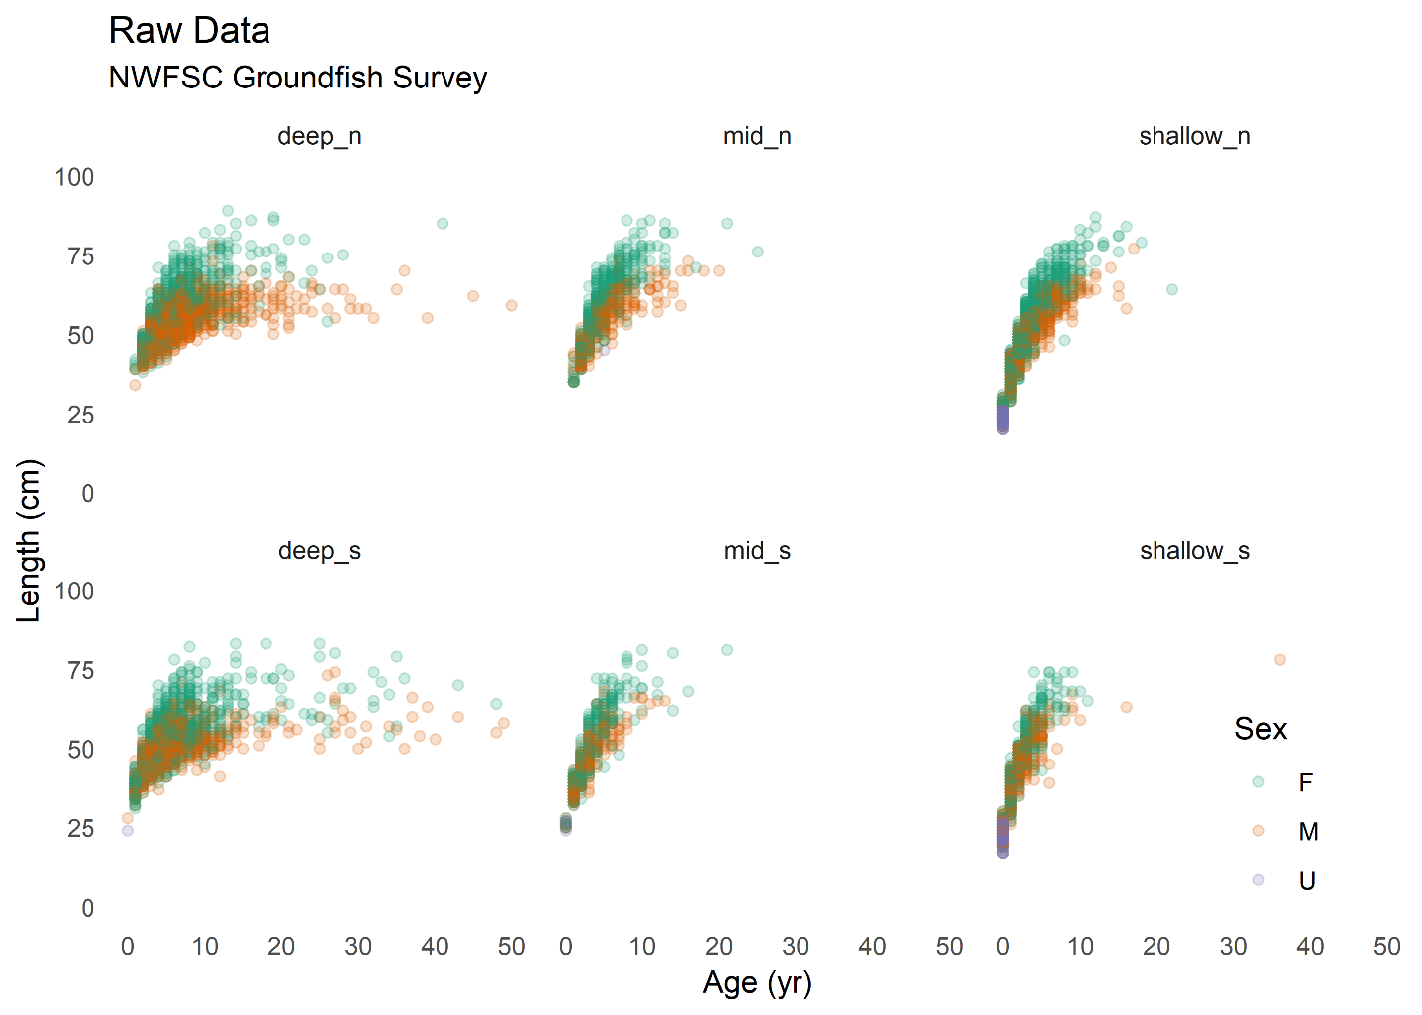

Figure 1. Raw length at age data from the U.S. West Coast groundfish bottom trawl survey, split by strata and colored by sex.

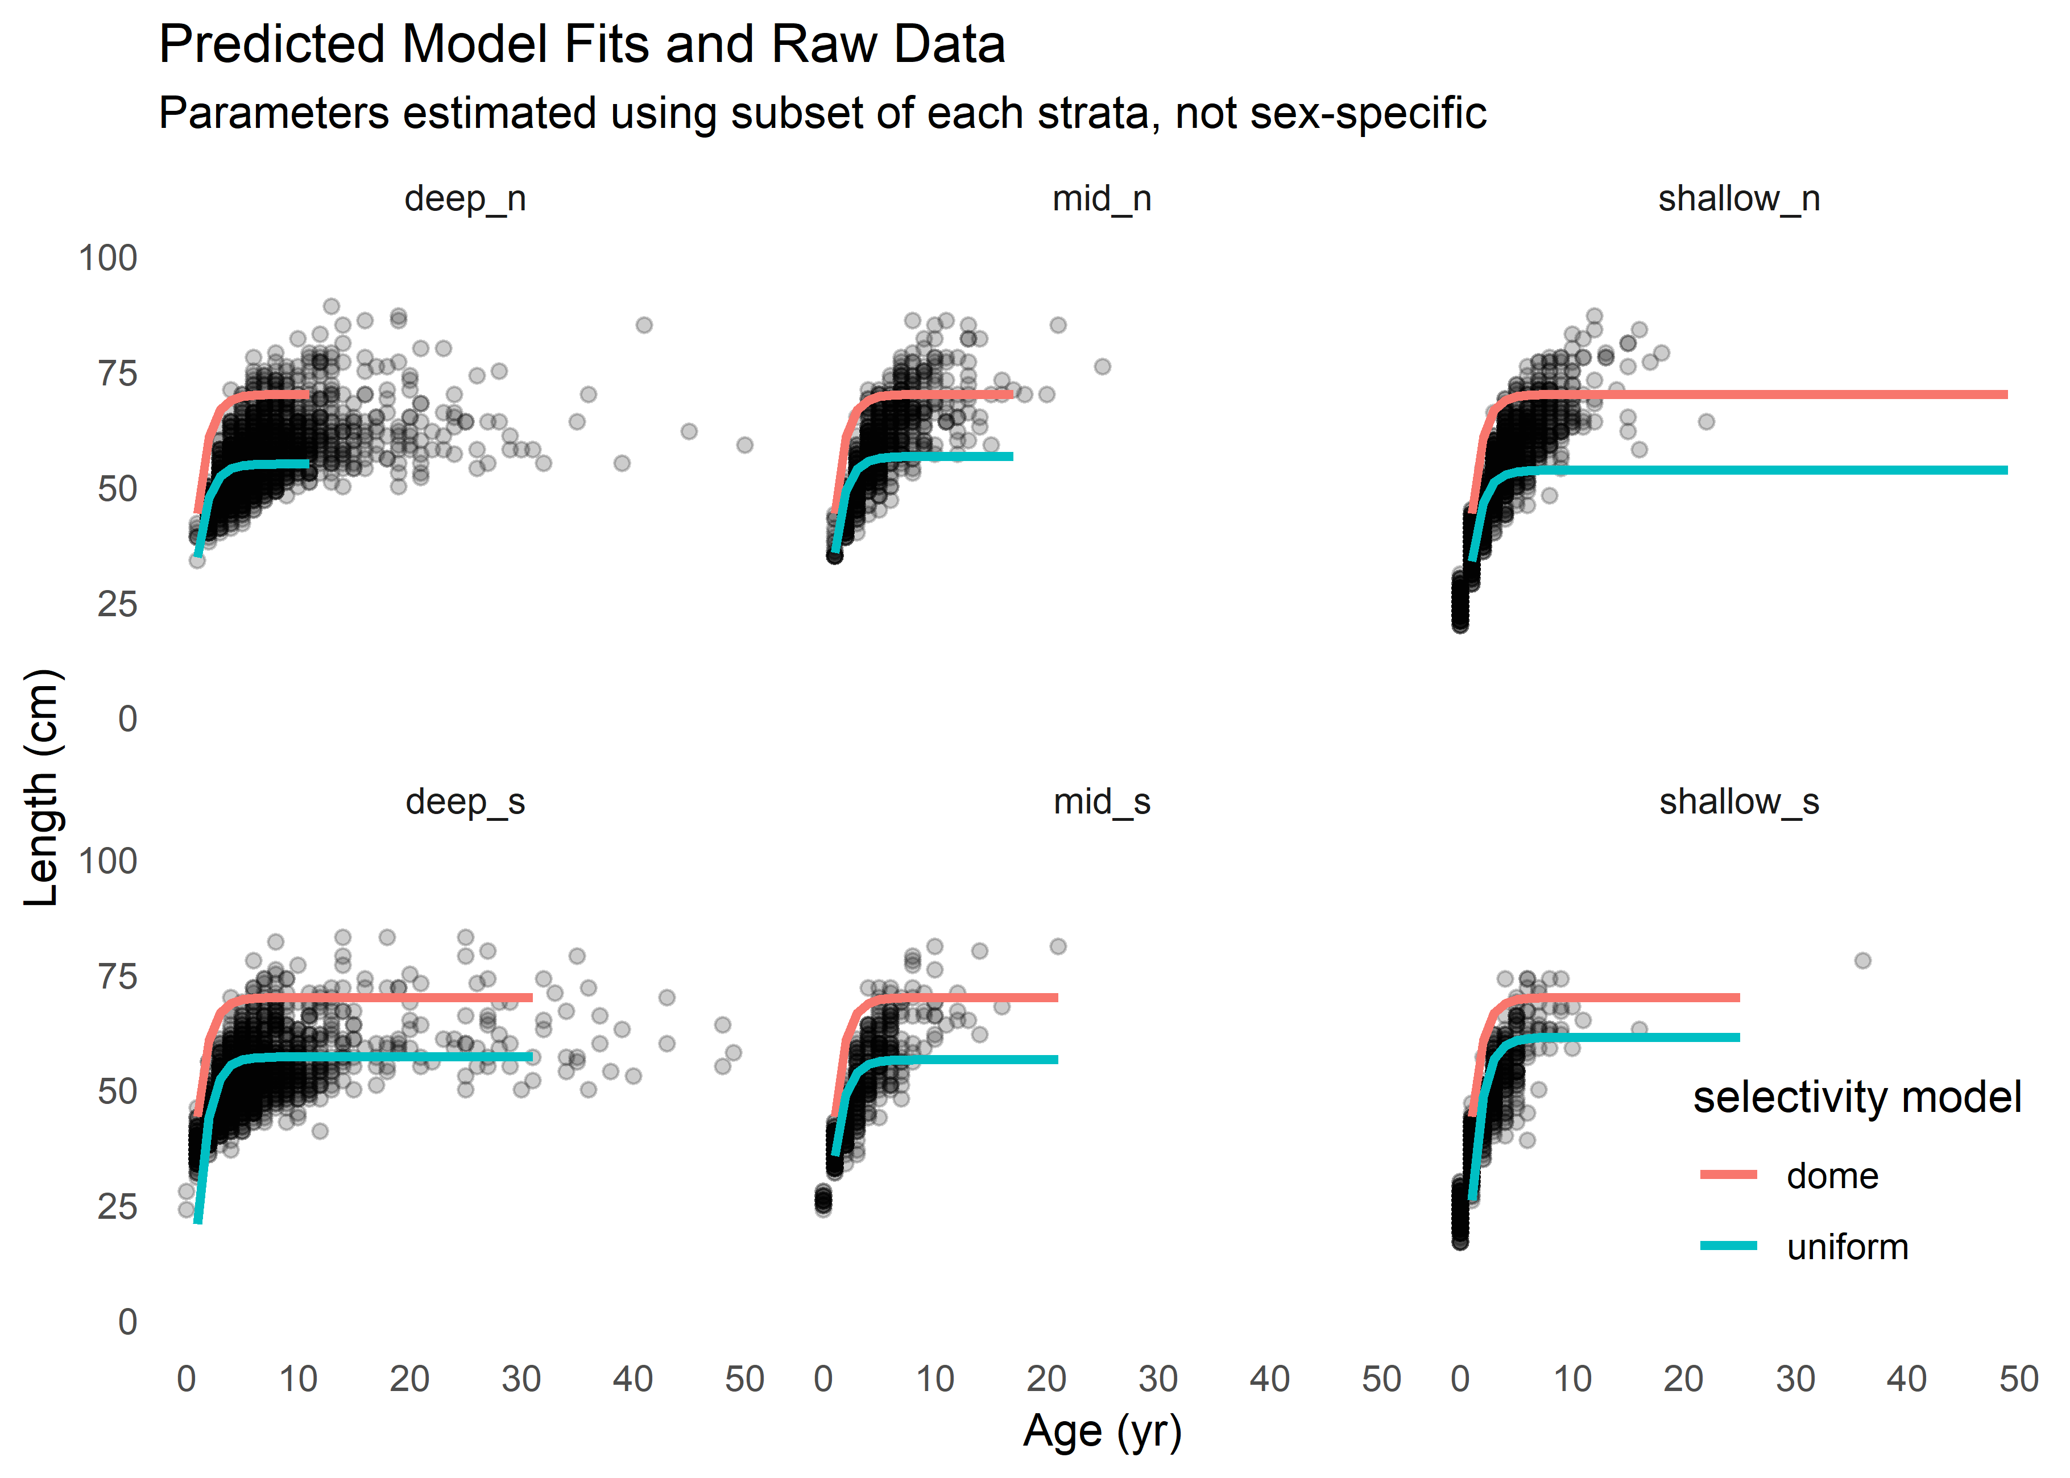

Figure 2. Model fits using uniform selectivity; parameters were fit to a subsample of 500 data points from each stratum.

Figure 3. Map of survey strata

Figure 4. Plots of selectivity curves

# Tables

|  |  |  |  |  |  |
| --- | --- | --- | --- | --- | --- |
| Region | Survey Method | Survey Frequency | VBGF parameters | | |
| L∞ | K | A0 (years) |
| West Coast of US (Johnson et al., 2015) | Trawl on chartered commercial fishing vessels | Twice annually between May and October | Obtained at age 30 |  | 0.5 |
| British Columbia |  |  |  |  |  |
| Alaska (Dana Hanselman et al., 2015) | Longline on chartered commercial fishing vessels | One three-month survey each year | 75.6, 80.2 (females, early and late period), 65.3, 67.8 (males, early and late period) | 0.208, 0.222 (females, early and late period), 0.227, 0.290 (males, early and late period) | -3.63, -1.95 (females, early and late period), -4.09, -2.27 (males, early and late period) |

Table 1. Overview of survey methods and most recent VBGF parameters used for sablefish in stock assessments.

|  |  |  |
| --- | --- | --- |
| Spatial Stratification | Selectivity Correction | Cutoff values (cm) |
| All strata estimated separately | None (uniform) | N/A |
| All strata estimated separately | Minimum only (logistic) |  |
| All strata estimated separately | Maximum only (negative logistic) | Deep_n = 14cm |
| All strata estimated separately | Minimum and maximum (dome shaped) | Bounded between minima and maxima by stratum |

Table 2. Description of N simulations used in comparison. For each scenario, the listed selectivity correction was applied to all strata, though the actual values for maxima and minima were selected based on known survey selectivity at each stratum

|  |  |  |  |  |  |  |
| --- | --- | --- | --- | --- | --- | --- |
| Spatial Stratification | Selectivity Correction | Estimated VBGF Parameters | | | | Log-Likelihood |
| L∞ (cm) | | K | A0 (years) |
| All strata estimated separately | None (uniform) | Deep_N | Shallow_n |  |  |  |
|  |  |
|  |  |
| All strata estimated separately | Minimum only (logistic) |  | |  |  |  |
| All strata estimated separately | Maximum only (negative logistic) |  | |  |  |  |
| All strata estimated separately | Minimum and maximum (dome shaped) |  | |  |  |  |

Table 3. Results of simulations with varied selectivity corrections.

# References

Adams, G.D., Leaf, R.T., Ballenger, J.C., Arnott, S.A., McDonough, C.J., 2018. Spatial variability in the growth of Sheepshead (Archosargus probatocephalus) in the Southeast US: Implications for assessment and management. Fish. Res. 206, 35–43. https://doi.org/10.1016/j.fishres.2018.04.023

Hanselman, D.H., Heifetz, J., Echave, K.B., Dressel, S.C., Jech, J.M., 2015. Move it or lose it: movement and mortality of sablefish tagged in Alaska. Can. J. Fish. Aquat. Sci. 72, 238–251. https://doi.org/10.1139/cjfas-2014-0251

Hanselman, D.H., Lunsford, C.R., Rodgveller, C.J., 2015. Assessment of the sablefish stock in Alaska. Stock Assess. Fish. Eval. Rep. Groundf. Resour. Gulf Alaska 2014, 576–717.

Hurst, T.P., Abookire, A.A., 2006. Temporal and spatial variation in potential and realized growth rates of age-0 year northern rock sole. J. Fish Biol. 68, 905–919. https://doi.org/10.1111/j.0022-1112.2006.00985.x

Jasonowicz, A.J., Goetz, F.W., Goetz, G.W., Nichols, K.M., 2017. Love the one you’re with: genomic evidence of panmixia in the sablefish ( *Anoplopoma fimbria* ). Can. J. Fish. Aquat. Sci. 74, 377–387. https://doi.org/10.1139/cjfas-2016-0012

Johnson, K.F., Rudd, M.B., Pons, M., Akselrud, C.A., Lee, Q., Haltuch, M.A., Hamel, O.S., 2015. Status of the U.S. sablefish resource in 2015.

Kristensen, K., Nielsen, A., Berg, C., Skaug, H., Bell, B., 2016. TMB: Automatic Differentiation and Laplace Approximation. ournal Stat. Softw. 70, 1–21. https://doi.org/10.18637/jss.v070.i05

McDevitt, M., 1990. Growth Analysis of Sablefish From Mark-Recapture Data From the Northeast Pacific. University of Washington.

McGarvey, R., Fowler, A.J., 2002. Seasonal growth of King George whiting (Sillaginodes punctata) estimated from length-at-age samples of the legal-size harvest. Fish. Bull. 100, 545–558.

Punt, A.E., 2003. The performance of a size-structured stock assessment method in the face of spatial heterogeneity in growth. Fish. Res. 65, 391–409. https://doi.org/10.1016/j.fishres.2003.09.028

Ricker, W., 1969. Effects of size-selective mortality and sampling bias on estimates of growth, mortality, production and yield. J. Fish. Res. Board Canada. https://doi.org/10.1139/f69-051

Schueller, A.M., Williams, E.H., Cheshire, R.T., 2014. A proposed, tested, and applied adjustment to account for bias in growth parameter estimates due to selectivity. Fish. Res. 158, 26–39. https://doi.org/10.1016/j.fishres.2013.10.023

von Bertalanffy, L., 1957. Quantitative Laws in Metabolism and Growth. Q. Rev. Biol. https://doi.org/10.1086/401873